EXHIBITOR
GUIDELINES

Health, Safety & Security


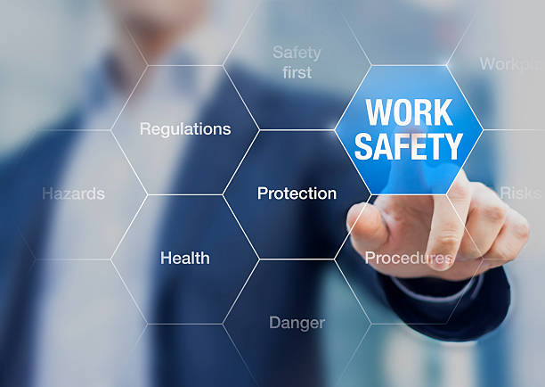


Table of Contents

Introduction 3
Accident Reporting 4
Deliveries 4
Children 5
Electrical Safety & Equipment 5
Drugs, Alcohol & Smoking 6
Designing Out Risk 6
Fire Safety & Means of Escape 7-11
Floor Loading 12
Food Safety 12
General Welfare 13
Glazing 13
Hot Works & Naked Flame 14
Housekeeping 14
Manual Handling 15
Medical Concerns at Informa Events 16-17
Personal Protective Equipment (PPE) 18
Risk Assessment & Method Statement 19
Safety Data Sheets (SDS) 19
Safety Equipment & Signage 20
Storage 20
Specialized Risk 21
Stand Structural Safety 22
Substances Hazardous to Health 22
Vehicle Movements 23
Venue Emergency Procedures 23
Working at Height 24-25
APPENDIX: EXHIBITOR & CONTRACTOR HEALTH & SAFETY DECLARATION 26

Introduction

Informa maintains high standards of Health & Safety and requires exhibitors and their appointed contractors to undertake their work in a safe manner that does not put themselves or others at risk. Exhibitors are required to appoint competent contractors who are appropriately health and safety trained to perform work, erect, and dismantle their stands. The standards and rules outlined in this document should be read in conjunction with the venue’s site-specific safety information.
Informa reserves the right to require the removal from the premises of any persons who do not comply with Informa or venue health and safety requirements, or who put themselves or others at risk. Informa similarly reserve the right the removal of any equipment or material that, in the opinion of Informa is dangerous when used in the way intended.
The aim of this guidance is to set standards which will assist protecting the health and safety of any person(s) working at or visiting an Informa event/exhibition. These guidelines should be used to guide employees, exhibitors, contractors, and Informa-approved contractors with regards to minimum safety standards in any jurisdiction whilst recognizing that many jurisdictions have higher standards that will take precedence.
Exhibitors, Contractors and EACs are to undertake their work in a safe manner which does not put themselves or others at risk.

EXHIBITOR HEALTH & SAFETY GUIDELINES

Accident Reporting
ALL accidents, incidents and near misses must be reported to Informa in order that treatment can be given if required and if necessary, emergency services can be called and directed to the correct location.
Informa will record and report all health, safety, and security related incidents internally. This will identify trends, confirm adherence to Informa Health, Safety & Security guidelines and address areas for actions and improvement.

Deliveries
Exhibitors & Contractors must make their own arrangements for the transport, delivery and handling of event equipment and materials whilst utilizing appointed logistics contractors. Informa Staff are not permitted to assist in moving goods and exhibition materials. Exhibitors & Contractors with large delivery containers must have an agreement with Informa and the venue, if additional safety arrangements need to be made.

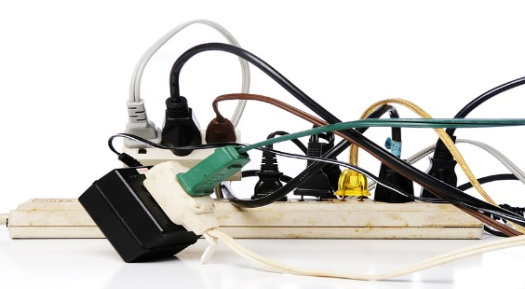
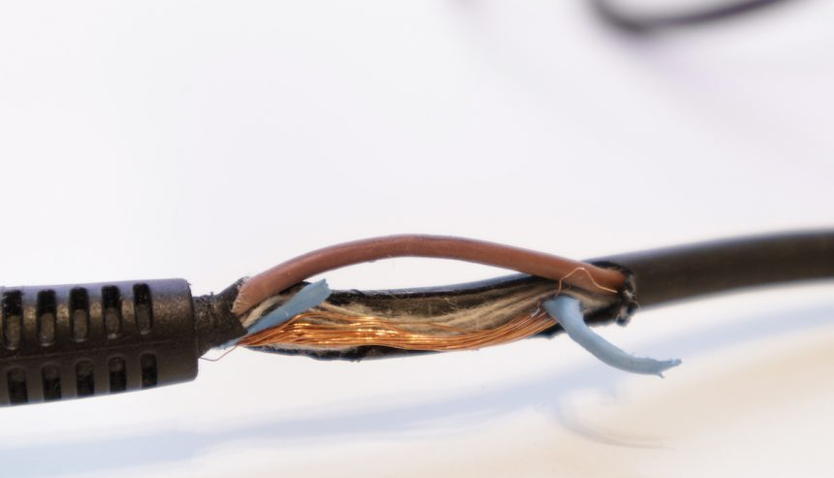
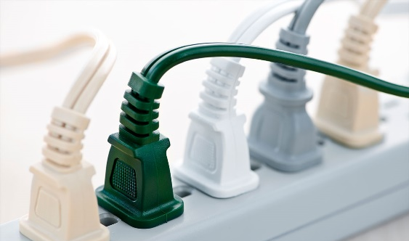


Electrical Safety & Equipment
The nominated contractor will liaise with the venue directly to ensure the installation is verified as safe prior to it being energized. Exhibitors and contractors that provide their own extension leads and adaptors are responsible for them being properly wired and electrically tested. All electrical equipment and extension cords used must be in sound condition, with all live conductors properly protected. Extension cords must not be connected known as daisy chaining. Inspected equipment must be clearly labelled with inspection labels.

Children
No one under the age of 16 years old is permitted in the exhibit halls during the build and breakdown phases of the event without permission from Informa.

Drugs, Alcohol & Smoking
The abuse of alcohol, drugs and other substances can affect work performance and safety. Such behavior constitutes a danger to themselves or other people. Any person found to be under the influence of such substances and in, the opinion of Informa and their representatives will be removed from the exhibition and event. The consumption of alcohol is not permitted in the exhibition hall during the build-up and breakdown periods. Smoking, vaping, and the use of tobacco products are not permitted in the exhibition halls. Individuals may smoke or vape only in the venues designated areas.
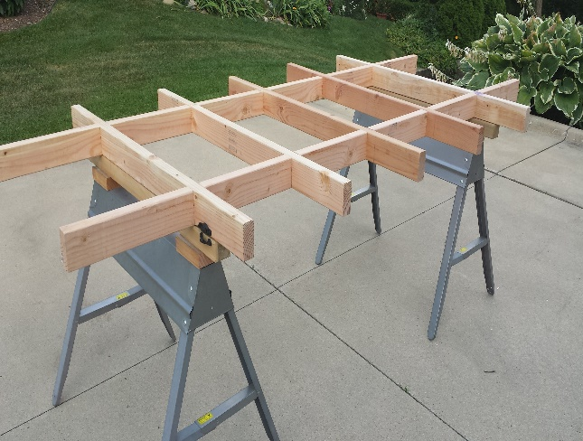
Designing Out Risk
The exhibitor and their contractors are expected to supply pre-cut and ready prepared exhibition stand materials onsite wherever reasonably practicable. This is in order to reduce the need to cut, work and paint materials onsite with associated dust, fume and noise hazards. Cutting and preparation of materials onsite should be the exception not the rule.
Fire Safety & Means of Escape
Stands with internal rooms or enclosed areas and seminar theaters must be installed with adequate means of escape through a combination of sufficient exits, clear exit signage, door furniture, safe exit routes and seating arrangements. Full details of the requirements in relation to seminar theaters and stands with internal rooms or enclosed areas including rooms with solid ceilings are provided below.
- Fire Safety of Stand Materials
  - Stand materials must meet the local requirements.
  - Boars, plywood, chipboard, etc under 18mm thick must be treated to ensure compliance with local requirements.
  - Plastic must conform to local requirements including plastic plants, trees, etc.
  - Polycarbonate materials such as Lexan and Makrolon are acceptable.

- Paints and Surface Treatments
  - Only water-based paints may be used on site. Paint spraying equipment is prohibited.
  - Fabrics and materials treated with fire resistant solutions should not be over painted with water-based paints.

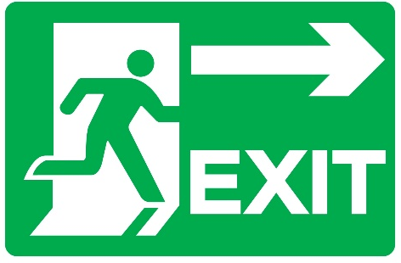


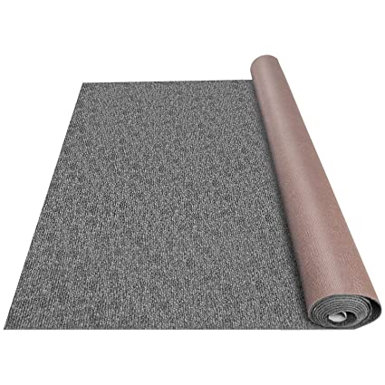
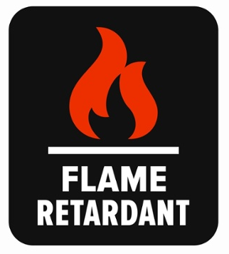
Fire Safety & Means of Escape (cont)
- Fabrics & Decorative Materials
  - Fabrics and other decorative materials used for stand dressing must be fire resistant or treated with fire retardant, in accordance with local requirements. Where the venue has a sprinkler system then the specific venue rules on permitting ceiling fabrics must be followed. Untreated wallpaper and similar thin surface finishes, not exceeding 1mm in thickness may be accepted, provided they are fixed firmly with an approved adhesive.

- Night Sheets
  - Only night sheets that are fire resistant or treated with a fire retardant are permitted to be used in locations that do not obscure fire exits from stands.

- Floor Coverings
  - Carpets, drugget, matting, crumb cloths and other textile floor covering, and under-lays must comply with local requirements. Floor coverings shall be secured and maintain so that it will not cause a hazard. Mats shall be sunk, so they are flush with the floor of the stand. Fixing of floor covering may only be done with the industry standard tape. Other forms of fixing such as cable clips, nails or bolts are strictly prohibited.
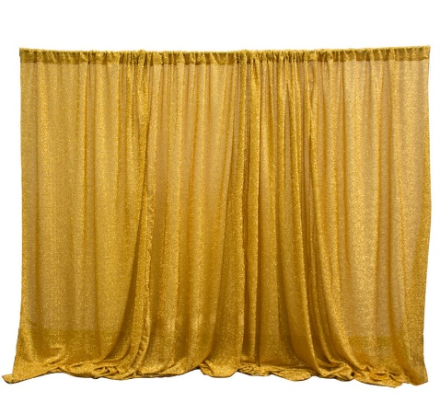
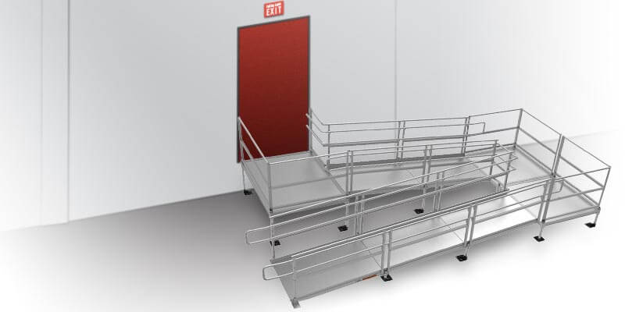
Fire Safety & Means of Escape (cont)
- Drapes, Curtains & Hangings
  - Drapes, curtains, hangings and like decorations shall be fire resistant and comply with local requirements. Otherwise, they may be treated with proprietary fire retardant. Curtains on exit routes should hang 75mm clear of the ground, be parted in the center and not conceal and exit signs.
  - If Informa is not satisfied that any material meets the standards required, they shall be removed from the exhibition hall.

- Vertical Escapes
  - Ramps
    - The slope of any ramp shall be uniform and no steeper than 1:12. Level landings shall be provided at the top and bottom of ramps and any intermediate position where exits doors open on to them.
    - The surface of any ramp should be imperforate and non-slip in texture.
    - The minimum width of a ramp provided for use by the disabled should be 1m or local requirements.
    - All ramps and landings should have clear headroom throughout of at least 2m or local requirements.
    - Ramps should be clear of permanent obstructions.
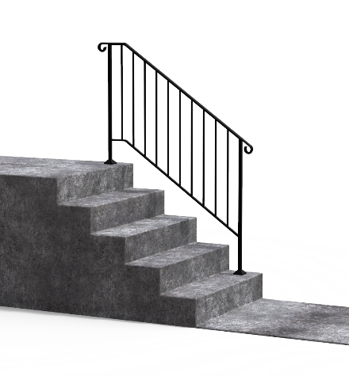
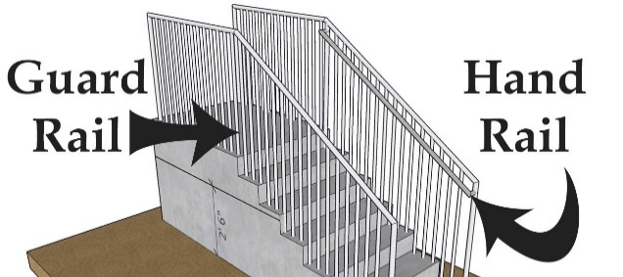
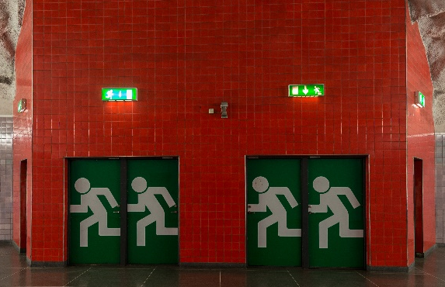
Fire Safety & Means of Escape (cont)

- Vertical Escapes
  - Handrails
    - A continuous handrail must be provided where there are two or more risers.
    - Stairs should have a handrail on at least one side if they are less than 1m wide. They should have a handrail on both sides if they are wider.
    - Double width staircases shall have a central handrail.
  - Guarding of Stairs
    - Flights and landings should be guarded at the sides when there is a drop of more than 360mm or there are two or more risers. Guarding should be constructed so that:
    - 100mm sphere cannot pass through any openings.
    - Persons are not readily able to climb the guarding.
    - Guarding shall comply with local requirements.
  - Barriers
    - Barriers shall be provided to protect exposed edges of landings, balconies and other changes of levels exceeding 360mm.
    - Barriers shall be non-climbable with solid infills or vertical guardrails, which should be no more than 100mm apart without horizontal members between verticals.
    - Barriers shall comply with local requirements.

- Inner Rooms
  - In order to prevent dead ends, inner rooms must have an alternative means of escape, indicated with appropriate signage or alternatively smoke detection or vision panels installed between each area or an open common ceiling.
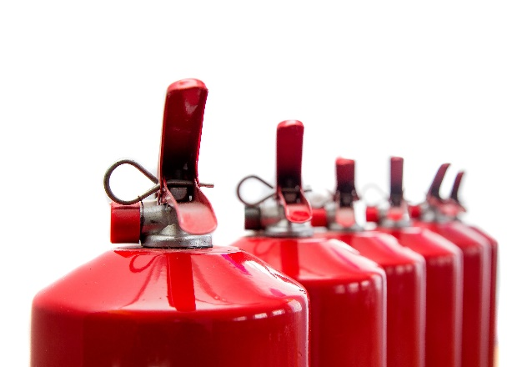
Fire Safety & Means of Escape (cont)
Venue Responsibilities
As per local requirements areas may include:
- Fire Suppression Systems
- Fire Extinguishers
- Fire Exit Signage
- Appropriate fire response protocols
- Proper storage and housekeeping protocols
- Ensuring maintenance is up to date
- Ensuring inspections are up to date
Fire Equipment & Means of Escape
Remember: Fire Extinguishers have a limited range and limited amount of extinguishers agent. They are effective against small fires. They should not be used in any of the following situations:
- You have not been properly trained to use a fire extinguisher
- The fire spreads beyond its immediate area
- The fire could block your escape routes
Individuals should familiarize themselves with the venue emergency protocols and ensure they have a plan in the event of an emergency. Emergency exit doors, fire pull stations, fire extinguishers and fire equipment shall not be obstructed at any time.
Floor Loading
The permitted loading on trucks, ramps and exhibition halls where relevant, is laid down in the separate floor loading information. Any anticipated plans to use lifting equipment with the halls including mobile cranes must be raised with Informa and the venue to ensure floor loadings are not exceeding
No fixings whatsoever may be made to the hall floors unless permission is explicitly granted by the venue.


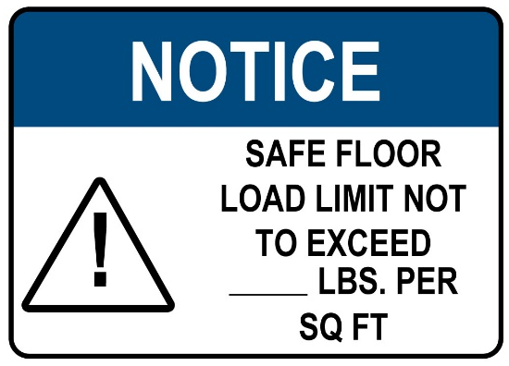
Food Safety
In collaboration with national, local and venue guidelines, Informa is committed to food safety and has a moral obligation to safeguard each other, our customers, and the consumers
It will be the responsibility to the venue to adhere to national and local government guidelines as it pertains to food safety. Informa will regularly measure compliance against the current standard and regulatory requirements.
Informa is unable to guarantee that an individual with food allergens will not be exposed accidently within the event environment. Informa will ensure reasonable efforts are in place to keep individuals’ risk to as low as reasonably practicable.

General Welfare
Exhibitors and contractors shall maintain a healthy and safe working environment. This includes but not limited to adequate space, temperatures, lighting, waste control, drinking water and rest areas.

Food shall not be consumed in the construction areas. Workers have an area for rest and 12-hour shifts are the maximum (unless under extreme/emergent circumstances) All requirements are subject to inspection by Informa.

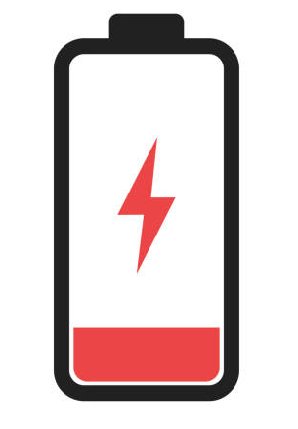

Glazing
All glazing must comply with local requirements. Any interrupted large areas of clear glazing, especially glazed doors, shall be indicated so as to be readily apparent (for example, by warning stripes, dots or logos) to ensure people do not injure themselves by inadvertently walking into the glass. Overhead glazing shall be of wired glass, laminated glass or be otherwise adequately protected from shattering.

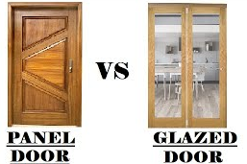

Hot Works & Naked Flame
Hot works such as welding, the use of grinders, soldering, etc., are prohibited unless advance notice is given to Informa and the Venue. Permission must be granted, and a specific hot work permit issued prior to commencement of work. Floor management will monitor hot works to ensure that they do not pose a fire safety risk. In general, the following must be in place:
- Immediate area must be clear of other works, public and vehicles
- Immediate area must be clear of combustibles
- The operative and others in the immediate area must be suitably protected from risk of burns and damage to eyes
- A suitable fire extinguisher must be provided near work area
- A second operative is required to monitor the operation, to keep other people clear and watch for signs of fire and utilize the fire extinguisher, if necessary.

Housekeeping
Contractors and exhibitors are required to maintain good standards of housekeeping and not obstruct corridors or emergency exits or deliver large storage containers (larger than standard freight containers) at the venue unless Informa has agreed to this, and alternative safety arrangements have been made. Combustible waste and rubbish must be removed from event areas and to the receptacles provided as soon as possible and always at the end of the working day. Any uncontrolled dumping of waste outside the bins allocated for this use is forbidden.

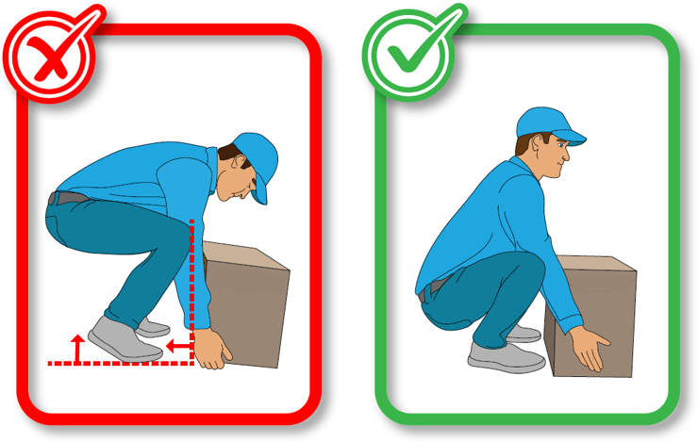
Manual Handling
Manual Handling is the movement of loads by lifting and carrying by hand. Where practicable, mechanical means should be used such as a lift trucks, pallet trucks and trollies to reduce the need for manual handling. There must be adequate lighting and clear aisles to allow loads to be carried without the risk of tripping and falling. Operatives moving loads should consider wearing safety boots. In conjunction with local and venue guidelines, heavy loads may need boots with toe protection to protect the feet from dropped loads.
Factors that should be considered when manual handling are:
- Weight of load
- Size and shape of load
- Posture during manual handling
- The distance the load has to be lifted
- Frequency of manual handling
- Working environment
- Capability of person

Medical Concerns at Informa Events
Medical Coverage
A large portion of Informa events are held at convention centers and towns with urban settings which includes hospitals and clinics in close proximity. Ambulance and emergency room services are generally minutes away. During events, Informa normally provides contracts out with the venue for a medical station on or near the exhibit floor. Staffed by EMTs and nurses with emergency medical supplies and equipment. The medical staff number varies with size of the event as does with the equipment. With some events there is an ambulance stationed at the venue.
First Aid
Venues generally have first-aid kits and a Security team that is trained in first aid. The quantity of supplies varies depending on the size of the venue and business operation. General Contractors, Exhibitor-Approved Contractors, and contractors hired by Informa are required to carry a first aid kit. Rendering first aid depends on the seriousness and urgency of the situation. Difficult first-aid situations such as CPR or handling and cleaning up blood borne pathogens should be handled by a competent and trained person.


Medical Concerns at Informa Events (cont)
Reducing the Spread of Infectious Diseases and Viruses
Infectious diseases and viruses go by many names, SARS, West Nile, Ebola, COVID-19, and the many forms of the flu, etc. Concern over the spread has the attention of the tradeshow and conference industry where business travelers gather across the world. Informa closely follows guidelines, advisories and alerts from international authorities, national authorities and local authorities are actions that Informa takes and requires in turn from contractors that work for Informa events:
- Informa will keep all its employees, event contractors, exhibitors and attendees apprised of specific advisories and alerts regarding dangers, cautions and control measures to reduce the spread of infectious diseases and viruses that are contagious.
- Informa employees are required to report any exposures to contagious disease that might pose a direct threat to the health and safety of the event
- Exhibitors and contractors are required to legally remove individuals who have a contagious disease from working at an Informa event. Return from sick time shall require that exhibitors and contractors inform and certify an original doctor’s note stating the patient is fit for work, and the possibility of infecting others is no longer present.
The best practices which have evolved, describing minor but effective changes in routine that will reduce the probability of disease spread:
- Get the appropriate vaccine, if available
- Wash your hands frequently
- Stay home if you are sick
- Turn away from others and cough or sneeze into your arm/elbow (not your hands)
- Do not touch your eyes, nose, or mouth (viruses can transfer from your hands into the body)
Additional event/venue control methods may be applied based upon international, national and/or local recommendations or requirements

Personal Protective Equipment (PPE)
PPE shall not be relied on as a primary or only means of protection. It is to be used in conjunction with engineering controls, guards, and operational practices. Exhibitors and contractors have a duty to ensure the health and safety of personnel in the workplace; this may require the provision of PPE. Exhibitors and contractors are responsible for ensuring that workers are issued with appropriate PPE for their work activities.
During the build and breakdown, closed-toed shoes are mandatory at all times.
All exhibitors and contractors shall establish their minimum PPE requirements during build and breakdown phases:
General Requirements
- Safety footwear with toe protection
- Hard hats
- High visibility vests
- Safety googles
- Ear protection
Specialist Requirements
- Hand protection
- Fall arrest equipment
- Respiratory protection
- Eye protection


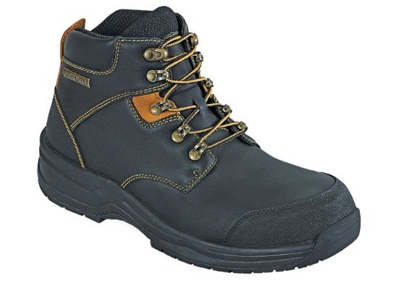
Risk Assessment & Method Statement
If required by local legislation, exhibitors and contractors will complete a risk assessment outlining to evaluate hazards, implement control measures to create a safer and healthier workplace.
Contractors will need to produce compliant method statements for activities that present a higher risk (as captured on their RAMs). These activities could involve lifting operations, electrical hazards, and potential fire risk situations.
The method statement should specify the operations to be carried out on a stage-by-stage basis and indicate the precautions necessary to protect contractors, delegates, staff, and members of the public who may be affected directly or indirectly by the work.

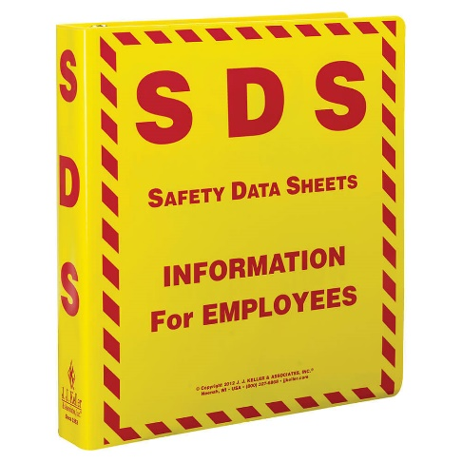

Safety Data Sheets (SDS)
Safety Data Sheets (SDS) are required to be readily available for any and all chemicals.
SDS are developed by chemical manufacturers or importers of each chemical or product supplied to record available scientific evidence in making hazard determination. They provide the following information to the consumer:
- Chemical common name(s) of the material(s)
- Physical and chemical characteristics of the material
- Physical and health hazards of the material
- Signs and symptoms of exposure
- Medical conditions aggravated by exposure
- Primary route(s) of entry
- Permissible exposure limits
- Precautions for safe handling and use
- Applicable control measures
- Emergency and first-aid procedures
- Name, address, and telephone number of party responsible for preparing the SDS
- Other related material regarding the hazardous material

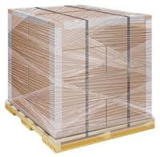
Storage
The following storage methods are strictly prohibited:
- Blocking emergency egress
- Blocking emergency exit doors
- Blocking fire safety equipment
- Storing combustible materials behind booth/stands
- Stacking storage/freight crates with the potential of falling
Storage containers must not be located on the venue premises except at locations agreed by Informa
Safety Equipment & Signage
Fire and Safety signage are provided by the venue, for example indicating escape routes, warning of hazardous materials, prohibited areas or no smoking. These signs must be obeyed at all times, unless given permission by the Informa and alternative arrangements can be made.
.
Specialized Risks
Unless specifically agreed in advance by Informa in writing the following goods and equipment are prohibited and will not be admitted onto the event:
- Flammable liquids or gases.
- Compressed gas cylinders.
- Radioactive materials.
- Radiation generators.
- Goods classified as hazardous including toxic, corrosive, irritant, harmful or oxidizing materials (except for small quantities of domestic cleaning materials)
- Any activity involving water where there is a risk of Legionella.
- Activities involving hot-works and subject to a specific hot work permit as detailed below).
- Explosive, pyrophoric, or spontaneous combustible
- materials.
- Other than Class 1 lasers or those in completely enclosed equipment.
- Equipment that may cause nuisance due to odor, emission of objectionable noises or stroboscopic or disturbing lights, simulators, and rides.
- Animals.
- Any machinery or equipment used must be in good
- condition, with dangerous parts effectively guarded.

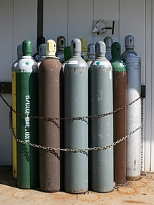

Stand Structural Safety
All stands are required to be structurally stable. The design of complex structures are required to be verified in compliance with local requirements. Examples of complex structures include but are not limited to:
- Structures over 4m in height and complex design or nature
- Multi-level stands
- Viewing/service platforms
- Suspended items (lights, signs, rigs)
- Raised walkways
- Ramps
- Sound/lighting tower
- Platforms and stages over 0.6m in height
Full details of complex structures must be submitted to Informa at least 30 days prior to opening the event. Any exhibits or materials displayed must be stable and adequately secured, as necessary, to avoid them from falling or posing a risk to those in the vicinity. Double-decker stands or stands higher than 4m are not permitted unless explicit permission has been granted by Informa.
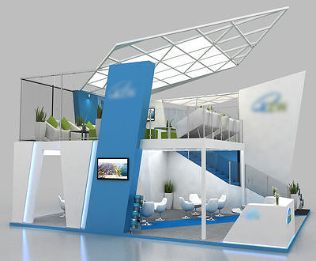
Substances Hazardous to Health
All chemicals used by the exhibitor or contractor must be kept in closed, correctly labelled containers and securely and safely stored at the end of the working day. The use of any chemicals must be carefully controlled to avoid unwanted exposure and nuisance to either the worker or other persons. Where activities might produce fume or dust or some other nuisance, then these activities must also be carefully controlled to ensure any nuisance is avoided. The exhibitor or contractor must have safe and legal transport and disposal arrangements for any chemicals used.

Venue Emergency Procedures
It will be the responsibility of the Informa to ensure relevant emergency procedures are understood and communicated to employees, contractors, and exhibitors. Venue fire and other emergency procedures, together with the emergency numbers for contacting fire, security or medical support shall be communicated.

Vehicle Movements
Exhibitors and Contractors must adhere to the restrictions and directions put in place and provided by the venue to ensure that vehicles and pedestrians are segregated. Vehicle drivers must:
- Adhere to venue and/or general contractors’ guidelines
- Not exceed venue/general contractor speed limits
- Wear a driver restraint (seat belt) while operating vehicle
- Announce (use horn) when moving from the loading area to event floor
- Not carry passengers unless they are seated with driver restraint in passenger seat
- Not load or unload in areas where it will block fire exits or routes
- Secure vehicle at all times and remove keys when unattended
- Not operate any vehicle whilst using a cellular device
.
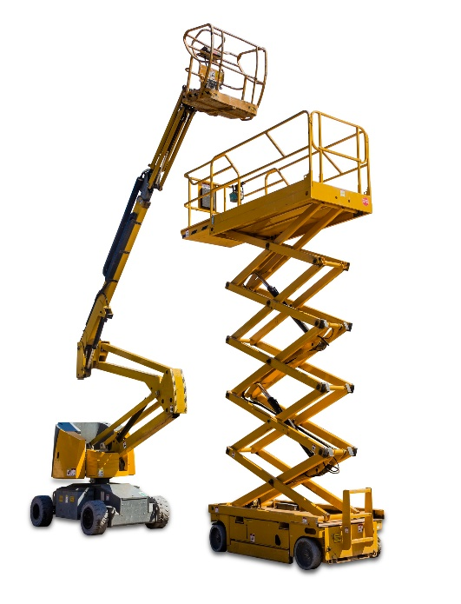
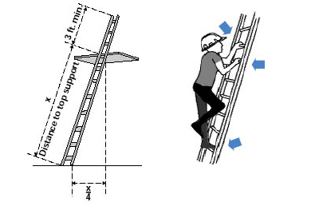
Working at Height
All reasonable steps should be taken to eliminate or minimize working at height. Working at height should be properly planned and supervised with the correct equipment selected for the given job task. Exhibitors and contractors are to ensure that:
    - No work is done at height if it is safe and practical to avoid it
    - All work at height takes account of conditions that could endanger safety such as high winds or slippery ground
    - Access is controlled to prevent other persons working or walking beneath or under working at height operations
    - The risk from falling objects is properly controlled. Work platforms must have a toe board to prevent items from falling
    - Plans are in place for emergencies and rescue from height
    - Those working at height must be protected by a guard rail and/or equipped with fall arrest harness (except whilst using a ladder)
    - Personnel involved in work at height are trained and competent
Ladders can be used when it is not practicable to use a mobile elevated working platform, or that activity is low risk. Ladders must be in accordance with manufacturer’s instructions at all times. The following guidelines must be followed:
    - Ladders must have an “industrial” rating
    - Leaning ladders must be placed at the correct angle
    - Ladders should be used on a level ground and must be secure
    - The top treads or steps must not be used as a platform for work
    - Users should face the ladder at a times whilst climbing or dismounting
    - Only one person should climb or work from a ladder
    - Users should not overreach

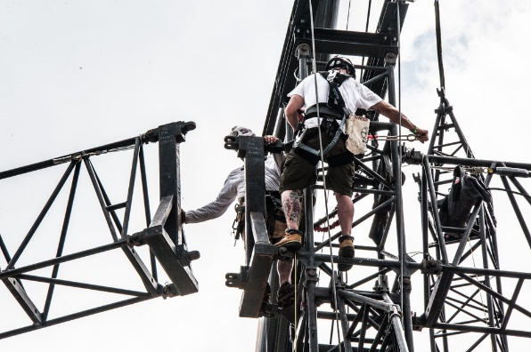
Working at Height (cont)
All rigging operations must be properly planned in advance with regard to permitted working load limits. Rigging operations must be undertaken and supervised by competent persons who are qualified by provision of appropriate skills, knowledge, training, and experience. Certificates must be readily available upon request. Exhibitors and contractors are not permitted to conduct their own primary rigging. Only appointed or approved contractors are permitted to conduct rigging operations from any part of the tenanted area.
Rigging equipment must be free from defects, fit for purpose, marked to indicate its working load limit, adequately maintained and subject to relevant legal requirements for inspection with valid certification must be available upon request.
All rigging equipment must be visually inspected daily by a competent person to ensure it can function safely. The Event Delivery Team Floor Management will monitor rigging operations to ensure they are conducted in safe manner:
- Where possible, all personnel should be excluded from the areas where overhead rigging or lifting operations are taking place
- Ensure sufficient time is available to ensure that rigging operations can take place safely
- Whilst working at heights, riggers must be clipped on to a rigging point via a safety lanyard or fall arrest equipment
- Suitable head protection must be worn to prevent injury to the head

APPENDIX: EXHIBITOR & CONTRACTOR’S HEALTH & SAFETY DECLARATION

FOR EXHIBITORS and CONTRACTORS:
Stand #
Name:
Date:
Position
Mobile #
Email
Declaration  Authorized By: | Name:  Initials:
By initialing this form, you acknowledge that you have read and understood the guidelines presented.

Individual with Overall Responsibility for Health & Safety Onsite:
Name
Position
Mobile #
Email

www.informa.com

