How to book your discounted RENFE ticket

**1.** Click here to download the authorisation that is needed to get this discount.

**IMPORTANT: Beneficiaries of the discount are required to carry this authorisation (either in print or in digital PDF format) during their journey. They may need to present it alongside their ticket if requested by RENFE personnel.**

**2.** Open [Renfe.com](https://www.renfe.com/es/en)

**3.**Select your Departure station and your Arrival station where the event is being held. Then select the travel dates, which must fall within the dates of XX April to XX May.

**4.** Select any price and option available at time of purchase (Básico (Economy), Elige (Pick & mix) or Prémium (Premium)).

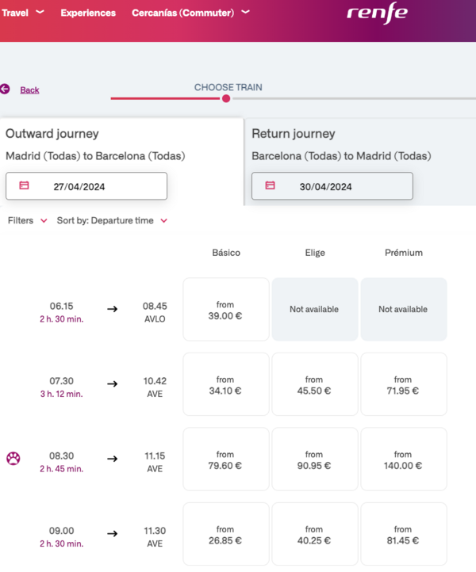

**5.** Then click on the Discount drop-down menu and proceed as follows:

* Select **"Congresos/Ferias"**

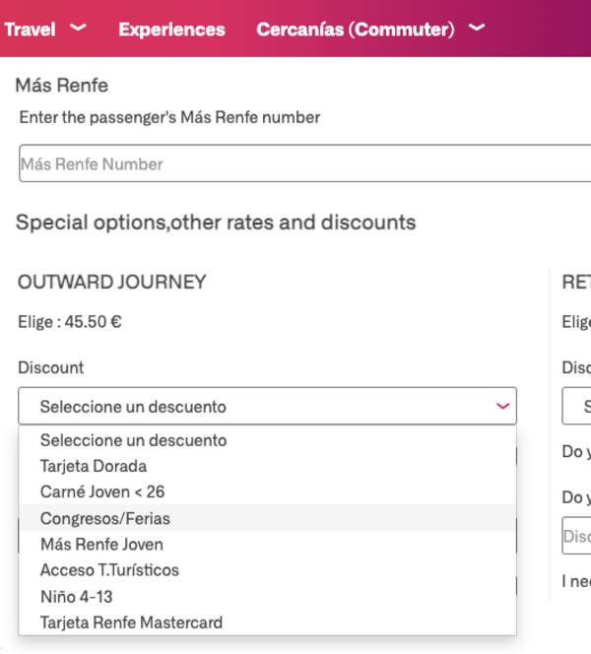

* Enter the **authorisation number xxxxxxxx from the downloaded document** in the box below the header, "Número Autorización".

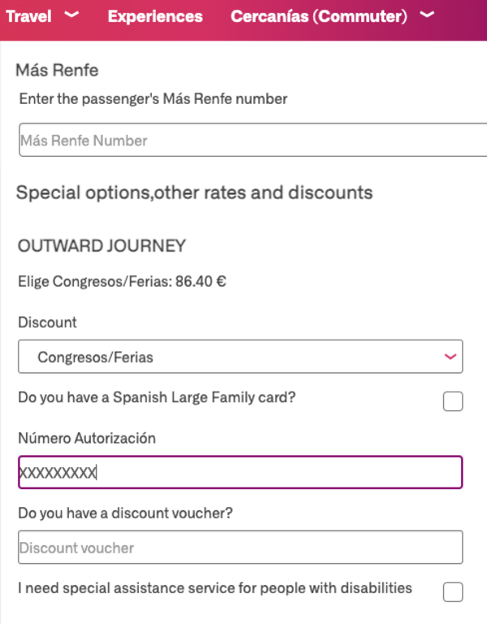

**6.** Proceed with the purchase and payment process.